Shadow Proxy
Shadow-proxy:
Since we need to save as many draw calls as possible, we will create a shadow proxy for most of the objects we have in the game. It helps because shadow-map rendering doesn't care about any surface property of a material, only geometry, so we can actually merge what would be many drawcalls into one. Shadow proxy is an optimized geometry of the model without alpha-blended parts (decals mostly) with a dedicated single material ID and a shadow proxy sub-material set in CryENGINE material.
The process is explained here, so please take a look at the CryENGINE documentation
Warhorse Shadowproxy pipeline guideline:
!!! We use shadow proxy only for the LOD 0 and LOD 1 !!!
The generation of shadow proxy is quite the same as the LOD except that we get rid of all the decals and alpha id material to keep only the "hard" mesh.
For the LOD 0 be careful to keep enough resolutions in the decimation/ optimization. This is because the player is going to navigate in the middle of those shadow proxy (as it is LOD 0) and pay more attention to the roof and the wall as some artifact might be visible
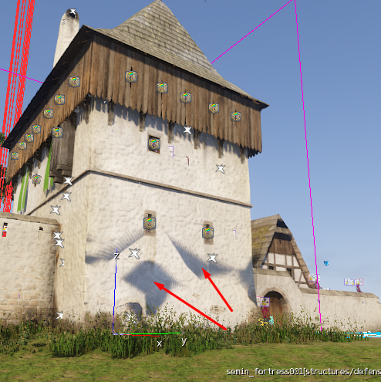
For the roof I recommend staying at least around 60-65% of reduction, sometimes it is necessary to do some manual fix on the shadow proxy, we can use a Push modifier or just move the vertices by hand.
Here the corner has to be excluded from the shadow proxy and uncheck "no shadow" in the material ID.
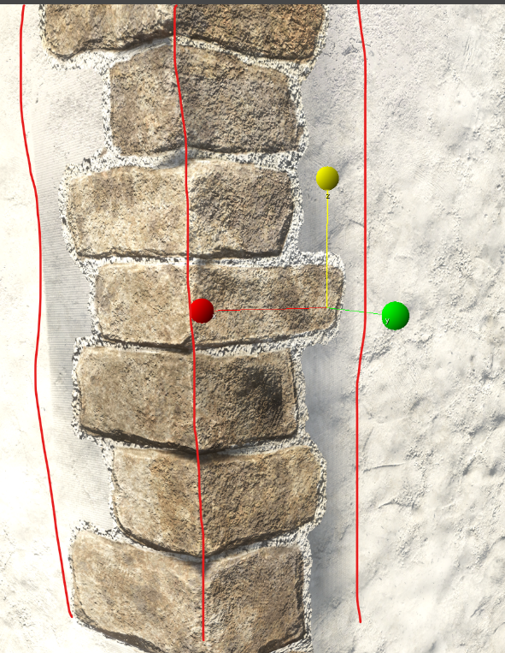
Material tweaks:
After you export it, you have to do some tweaks in the editor:
you MUST fill in texture textures/defaults/white_diff.tif and setup Diffuse color to the overall asset color
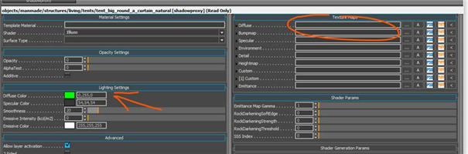
So we must have filled diffuse slot for texture in shadow-proxy, so we use a basic
256x256 white texture.
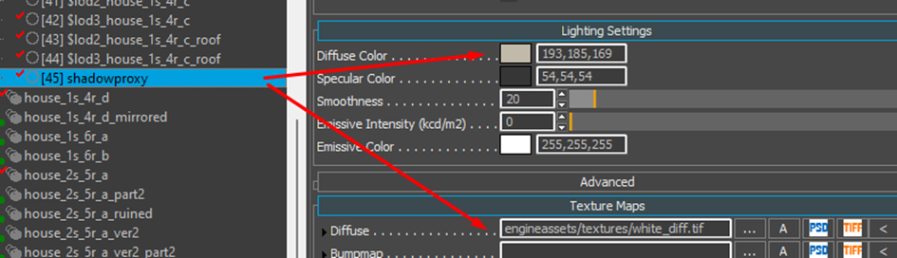
All the other mat id have to have the "No Shadow" checked with as exception of the thatched roof id, hay, stone corner, straw etc.
This exception can be applied as well to the roof-edge borders that are using also alpha cutout to have a correct shadow cast on the floor. But be careful for that last part as if it is a roof from a tall building, there is no need to do so as it is so far from the ground that it wouldn't have any real visual impact.

